

**MCA Semester – III**

**Front End Development Project**

|  |  |
| --- | --- |
| **Name** | **R Nandini** |
| **USN** | **231VMTR00212** |
| **Elective** | **FULL STACK DEVELOPMENT** |
| **Date of Submission** | **12 September 2024** |



**Front End Development Project - Report**

Project Report submitted to Jain Online (Deemed-to-be University) as part of the course “Front End Development Project”

**Master of Computer Applications**

*Submitted by*

**R Nandini**

USN

(231VMTR00212)

*Under the*

*guidance of*

(Nikhil Eknathrao Karale)

**DECLARATION**

I, *R Nandini,* hereby declare that this Project Report has been prepared by me under the guidance of *Nikhil Eknathrao Karale.* I declare that this Project is towards the partial fulfilment of the credit requirement for the course “Front End Development Project,” which is part of the Master of Computer Applications degree given by Jain University, Bengaluru. I declare that the work done by me towards this Project is original in nature and is my own contribution.

Place: Bengaluru *R Nandini*

Date: 12/09/2024 *231VMTR00212*

**CERTIFICATE**

This is to certify that the Project report submitted by Mr./Ms. *R Nandini* bearing *(231VMTR00212)* on the title **“Front End Development Project”**is a record of project work done by him/ her during the academic year 2023-24 under my guidance and supervision in partial fulfilment of Master of Computer Applications.

Place: Bengaluru

Date: *Nikhil Eknathrao Karale*

**ACKNOWLEDGEMENT**

We would like to extend our heartfelt gratitude to everyone who has supported and guided us in the successful completion of this Front-End project. We are deeply thankful to our Project Guide **Mr. Nikhil Eknathrao Karale**, whose invaluable expertise, encouragement, and constructive feedback have been instrumental in shaping the direction and quality of our work. Their guidance has helped us overcome challenges and achieve our research goals.

We would also like to express our sincere appreciation to our Program Manager **MS/Mrs. Sonia Walia** for their continuous support, encouragement, and coordination throughout this project. Their commitment to our development and their dedication to fostering a productive learning environment have been a source of great motivation.

In addition, we are grateful to the university officials and faculty members who provided us with the necessary resources and facilities, enabling us to conduct this research effectively. Their dedication to academic excellence has greatly inspired us.

Finally, we would like to acknowledge the encouragement and support of our friends, family, and peers, whose patience and understanding have been invaluable throughout this journey.

Thank you to each and every one who contributed to the success of this project.

R Nandini

231VMTR00212

**EXECUTIVE SUMMARY**

This project is a comprehensive, interactive web application developed to provide an engaging user experience for travel and booking services. The website combines an attractive design with intuitive functionality, offering a range of options for users to explore destinations, browse packages, and book trips.

1. **Welcome Page & Navigation**  
   The landing page features a clear, organized navigation bar that includes the brand logo, primary links, and a “Packages” dropdown menu for country-specific options. The "Login" and "Register" buttons are accessible for user account management. Below the navigation, a full-screen hero image introduces visitors to the brand with a welcoming message and dynamic country names that automatically rotate, inviting users to “Visit [Country Name].” A central "Book Now" button on the hero image directs users to booking options.
2. **Booking Section**  
   Below the hero section, a split layout displays a brand-related image on the left and a user-friendly booking form on the right. The form includes options like destination, number of people, start and end dates, and a description field, with JavaScript-based validation to ensure required inputs. Once completed, the "Book Now" button confirms bookings with an on-screen success alert.
3. **Packages Gallery**  
   In this section, users can view nine travel packages, organized in three rows with three packages each. Each package is represented as a card, displaying an image, location name, brief description, price, rating, and a "Book Now" button, making it easy for users to explore and select travel options.
4. **Services Section**  
   This area highlights the services offered by the company, including accommodations, food and drinks, and safety guidance, among others. The section’s design allows for flexibility, enabling users to interact with service details in a visually appealing way.
5. **Gallery & About Us Sections**  
   A gallery showcases images that reflect the experiences and destinations provided by the company. Each image includes a CSS scale transform effect on hover, enhancing the visual appeal. Following the gallery, an "About Us" section in a split format shares company history and values alongside another brand-related image.
6. **Footer**  
   The footer contains the brand name, social media icons, and a copyright message, ensuring brand visibility across the site.
7. **User Authentication & Forms**  
   The Register button triggers a Bootstrap modal (or an alternative registration page) with a form requesting personal details, validated via JavaScript. The Login button also triggers a modal (or login page) containing fields for email and password, with a link to registration for new users.

This project successfully integrates front-end technologies with thoughtful design principles, providing users with a streamlined, responsive, and visually engaging experience for exploring destinations and booking travel packages. The deployment on GitHub or Netlify further enhances accessibility and ease of use.

**TABLE OF CONTENTS**

|  |  |
| --- | --- |
| **Title** | **Page Nos.** |
| Executive Summary | 7 |
| Introduction | 9 |
| Objectives | 10 |
| Project Description | 12 |
| Additional Features | 14 |
| Flowchart | 16 |
| Coding | 17 |
| Output | 20 |
| Validation | 24 |
| Conclusion | 27 |
| References | 28 |

1. **Introduction**

In today’s digital age, travelers increasingly seek online platforms to explore, book, and plan trips efficiently. Many existing travel websites, however, fail to provide a streamlined experience due to outdated designs, limited interactivity, and non-intuitive navigation. Users desire a seamless, engaging platform where they can easily browse destinations, view packages, and make bookings without confusion or frustration. To meet these expectations, this project seeks to create an engaging, user-friendly travel booking website that offers a modern, responsive, and visually appealing solution.

**Problem Statement**

The current challenge for many travel websites is the lack of cohesive design, intuitive navigation, and interactivity needed to enhance user engagement. Many platforms do not prioritize user-centered design, resulting in user frustration, lower engagement rates, and, ultimately, fewer conversions. The core problem lies in delivering a visually engaging interface that also simplifies the booking process, provides clear information on destinations, and ensures accessibility across devices.

**Solution Overview**

This project provides a high-quality, interactive travel booking website that is accessible, visually attractive, and easy to navigate. The website structure includes several key features to guide users through the booking journey: a navigation menu with dropdowns, a welcome section with dynamic text, destination packages displayed in cards, a services section, and an image gallery with hover effects. It also includes forms with real-time validation for smooth user interactions, as well as a "Book Now" button to initiate bookings. By integrating Bootstrap’s responsive framework, the site ensures optimal display on devices of all sizes, enhancing accessibility and usability.

**Significance**

The solution’s significance lies in its ability to address the primary user pain points in online travel booking. It enhances engagement by creating an attractive, easy-to-use platform where users can intuitively explore travel options, view packages, and book trips. A streamlined booking experience reduces bounce rates and encourages users to complete their transactions, while the dynamic gallery and responsive design maintain engagement.

**Technology Rationale**

* **HTML**: The project’s backbone, HTML, organizes the website’s content, ensuring clear and semantic structuring of each section. HTML facilitates easy navigation for users and improves accessibility for search engines and assistive devices.
* **CSS**: CSS brings the website to life with styling, hover effects, layout adjustments, and animations. With CSS, the project creates visually appealing elements like hover effects on the gallery images and other subtle transitions that enhance the user experience without overwhelming the design.
* **JavaScript**: JavaScript is essential for adding interactivity, managing form validations, and controlling dynamic text changes. These features contribute to a smooth, engaging, and responsive website experience, offering real-time feedback and interactive elements that keep users engaged.
* **Bootstrap**: Bootstrap supports a responsive, grid-based layout that ensures a consistent experience across devices. Its pre-designed components, such as buttons, dropdowns, and modals, allow for faster development and help maintain design consistency, especially for mobile views and quick layout adjustments.

This combination of HTML, CSS, JavaScript, and Bootstrap allows the project to effectively address user needs for usability, responsiveness, and visual engagement, ultimately providing a reliable and modern booking experience.

**Objectives**

**2.1 Checkpoint - 1**

To create an engaging and intuitive welcome page with a user-friendly navigation menu that enhances user experience and reflects brand identity. The navigation should guide users through key website sections while also providing quick access to essential features.

Detailed Objectives:

1. Navigation Design: Establish a navigation bar with brand name/logo for easy brand recognition. Include essential menu items such as Home, Book, Packages (with dropdowns), Services, Gallery, About, and options for Login & Register to ensure easy accessibility to all key pages.
2. Dropdown Functionality: Enhance usability by adding a dropdown menu under the “Packages” section, with destination-specific options for United States, India, France, and Germany.
3. Background Image and Centralized Content: Display a full-width, high-resolution background image below the navigation menu. Center-align the following elements on this image:
   * Heading text: "Welcome to [Brand Name]"
   * Animated subheading: "Visit [Country Names]" (with names changing at intervals)
   * “Book Now” button

**2.2 Checkpoint - 2**

To provide users with a simple, interactive booking experience and a visually appealing package gallery to explore travel destinations, ultimately facilitating informed booking decisions.

Detailed Objectives:

1. Booking Form Section:
   * Divide the section into two halves: a brand-related image (left) and a booking form (right).
   * Design the booking form with fields for destination selection, number of persons, date pickers for travel period, a description field, and a “Book Now” button.
   * Ensure proper validation so users receive an alert message confirming successful booking when form fields are filled correctly.
2. Package Gallery:
   * Display a gallery with a 3x3 grid (3 packages per row, 3 rows) showcasing a total of 9 packages.
   * Design each package as a card with an image, destination name, brief description (attractions), price, rating, and a “Book Now” button to simplify the package selection process.
3. Services Section:
   * Create a visually appealing layout to showcase at least six services, with options like Affordable Hotel, Food & Drinks, Safety Guide, and three additional custom services.
   * Utilize a design style (e.g., cards, bullet points, or sliders) that suits the website’s aesthetic and effectively communicates service value.

**2.3 Checkpoint - 3**

To highlight the range of services offered and provide a gallery of brand experiences to build trust and enhance brand credibility.

Detailed Objectives:

1. Gallery Section:
   * Design a responsive gallery to display images that capture the essence of the travel experiences provided.
   * Add a CSS transform scale effect to images so they slightly zoom on hover, making the gallery interactive and visually engaging.
2. About Us Section:
   * Divide the section into two halves: an image related to the brand (left) and brand/company information (right), covering establishment details and unique selling points.
3. Footer Design:
   * Create a footer with brand name and inactive social media icons for visual consistency.
   * Add a copyright notice, including a message like “All Rights Reserved.”

**2.4 Checkpoint - 4**

To implement user authentication, establish a clear and informative footer, and deploy the website for public access on a reliable platform like GitHub or Netlify.

Detailed Objectives:

1. Register Modal/Page:
   * On Register button click, open a modal or redirect to a register page with fields for Full Name, Contact, Date of Birth, Email, Password, and Gender.
   * Add JavaScript validation to ensure form fields are properly filled before submission. Below the Register button, provide a link to redirect users to the login page.
2. Login Modal/Page:
   * On Login button click, open a modal or redirect to a login page with fields for Email and Password, along with a login button.
   * Provide a link below the login button to redirect to the register page.
3. Website Deployment:
   * Deploy the website to GitHub or Netlify to make it accessible to users, allowing them to explore the features seamlessly.

**3. Project Description**

**3.1 Checkpoint - 1**

The homepage of the website is the first point of interaction for users. It will include a navigation menu at the top with the brand's name or logo, positioned on the left side. The brand logo or name is designed to make the website visually appealing and establish a strong brand identity. To the right of the logo, there will be six key navigation links: Home, Book, Packages, Services, Gallery, and About. The Packages menu will contain a dropdown that appears when the user hovers over it, displaying four country options: United States, India, France, and Germany. To the far right of the navigation bar, there will be buttons for Login and Register.

Beneath the navigation menu, a background image will cover the full width of the page with a height of 90vh (slightly less than the full height). The image will have high clarity and will set the tone for the website, ideally related to travel. On top of this background image, the following three components will be centered:

1. A heading that says “Welcome to [Brand Name],” giving users a warm introduction to the brand.
2. A second heading in a larger font that will read “Visit [PlaceName]” (cycling through 5-6 sample countries every 0.2 seconds).
3. A Book Now button, allowing users to proceed to the booking form or start exploring the packages.

These elements will be placed strategically to catch the visitor's attention and encourage them to engage with the site.

**3.2 Checkpoint - 2**

Moving onto the Booking Section, there will be a two-column layout. The left column will be dedicated to an image related to the company or a popular travel destination, while the right column will feature a detailed booking form. This form will have fields where users can enter:

* Where to: A dropdown list that contains sample travel destinations.
* How many people: A numeric input for the number of people going on the trip.
* Start Date: A date input field that only allows future dates.
* End Date: A date input field that accepts dates later than the selected start date.
* Description: A text area where users can provide more details about their trip (with a minimum of 50 characters and a maximum of 500 characters).
* Book Now Button: A button that, when clicked, will validate the form. If all fields are correctly filled, a JavaScript alert will pop up, confirming a successful booking.

After the booking form, there will be a Package Gallery Section, which will display travel packages in a grid layout. The gallery will have three rows, each containing three packages, for a total of nine packages. Each package will be presented in a card-style layout that includes:

* An image of the destination.
* A heading with the name of the place.
* A short paragraph describing the place's attractions.
* The price of the package in USD.
* A rating for the package.
* A Book Now button to redirect users to the booking section or allow them to book the package directly.

Below the package gallery, there will be a Services Section, where six services offered by the company will be listed. These services could include things like "Affordable Hotels," "Food & Drinks," and "Safety Guides," among others. Three of these services should be customized based on the brand's offerings. The services can be displayed using cards, bullet points, or a slider, depending on the chosen design style. This section will give users an idea of what other services they can avail themselves of when booking with the company.

Finally, there will be a Gallery Section, showcasing images from past trips, customer experiences, or any other visually appealing content. These images will feature a transform scale effect in CSS, so that when the user hovers over the images, they will slightly enlarge, giving the gallery a more interactive feel.

**3.3 Checkpoint – 3**

The next section of the homepage will feature a two-column layout once again. The left column will contain an image related to the company or brand, while the right column will provide detailed company information. This will include:

* The company’s establishment year.
* A brief description of the company’s mission and values.
* Other relevant information about the company’s history or services.

At the bottom of the page, the footer will include the brand name, links to the company's social media pages (e.g., Instagram, Facebook, Twitter), and a copyright notice. The social media icons will be inactive for now, but they should still be visually displayed. The footer will help users easily find the company’s social media presence, even if the links are currently placeholder links.

**3.4 Checkpoint - 4**

For the Login and Register functionality, a user will be able to click the Login or Register buttons at the top of the homepage. If using Bootstrap, clicking the button will trigger a modal that pops up, allowing the user to log in or register without leaving the homepage. Alternatively, if you are not using Bootstrap, clicking the buttons will redirect the user to separate pages (login.html and register.html).

The Register Form will ask for:

* Full name.
* Contact number.
* Date of birth.
* Email address.
* Password.
* Gender.
* A Register button to complete the registration process.

The form will also contain a link to the Login Page, in case the user already has an account. Additionally, JavaScript validation will be used to ensure that fields like email and password are properly filled out and meet the necessary format.

The Login Form will be a simplified version, asking only for:

* Email address.
* Password.
* A Login button to submit the form.
* A link to the Register Page in case the user does not have an account yet.

Both the login and registration forms will have proper CSS styling to make them visually appealing and ensure a positive user experience.

**4. Additional Features**

While the core functionality of the **Travel Booking Website** involves navigation, booking forms, package galleries, and user registration/login, I’ve incorporated several additional features and enhancements that enhance the user experience, improve usability, and make the website more interactive. These additions set the project apart and provide an added layer of polish to the final product. Below, I highlight the extra features I've implemented, why they were included, and how they contribute to the overall success of the project.

While the basic requirements mention form validation, I’ve gone a step further by implementing customized, in-depth JavaScript validations on several form fields to ensure smooth user interactions. Here’s a breakdown of the validations added:

* Email Validation:  
  When users enter an email address during registration or login, I’ve implemented a regular expression to validate the format of the email. This ensures the input is a proper email address (e.g., example@domain.com), helping to prevent errors and enhancing form integrity.
* Password Strength Validation:  
  During registration, the password field is validated for strength. The password must meet certain criteria such as:
  + Minimum length of 8 characters.
  + At least one uppercase letter.
  + At least one special character (e.g., @, #, !).
  + At least one number.

This feature was included to improve security, ensuring that users create strong passwords and enhancing the overall security of user accounts.

* Date Validation (Start and End Dates):  
  For the booking form, I’ve added validation for the start and end date fields to ensure that:
  + The start date is always in the future (i.e., no past dates).
  + The end date is later than the start date (no overlapping or contradictory dates).

This prevents users from accidentally submitting invalid or nonsensical dates, ensuring that bookings are logically correct.

* Textarea Validation:  
  The description textarea in the booking form validates the character count, ensuring that the description is within the specified range (50-500 characters). This helps to ensure that users provide adequate information without exceeding the maximum limit.

These additional validations contribute to the project's success by:

* Reducing Errors: Ensuring users fill out the forms correctly and as expected, minimizing the chances of incorrect or incomplete data being submitted.
* Improving User Experience: By providing real-time feedback and guidance to users (such as telling them what’s wrong with their input), these validations make the forms easier to use and reduce frustration.
* Increasing Security: Strong password validation ensures that user accounts are secure, contributing to the overall safety of the website.

To make the Package Gallery more engaging and user-friendly, I’ve implemented the ability to filter packages based on the destination or type of trip. This feature wasn't part of the original requirements but adds significant value. Users can quickly find specific types of packages by clicking on a filter (e.g., "United States," "Adventure," "Luxury," etc.), making the experience more tailored and efficient.

In line with the core requirements, I’ve added modal windows for both login and registration forms. However, the added enhancement is the smooth interaction and UX flow when these modals appear. When users click on Login or Register, the modals will open without leaving the current page, which prevents the user from having to navigate away from the homepage. Additionally, I’ve ensured that modal windows close smoothly, improving the overall interaction design.

These extra features and enhancements were added to ensure the **Travel Booking Website** is not only functional but also **user-friendly**, **interactive**, and **visually appealing**. The **JavaScript validations** make the booking process smoother and error-free, while the **UI enhancements** improve the overall look and feel of the website, giving it a polished, professional appearance. The **filterable gallery** and **interactive modals** elevate the user experience, offering additional features that make the site more personalized and easier to use.

By focusing on **usability**, **security**, and **aesthetics**, these additional features help build trust with users, keep them engaged, and ultimately lead to higher conversions (e.g., successful bookings). This project is designed to not only meet the basic requirements but also exceed expectations by providing a more intuitive and enjoyable user experience, which is crucial in today’s competitive digital landscape.

**5. Flowchart**

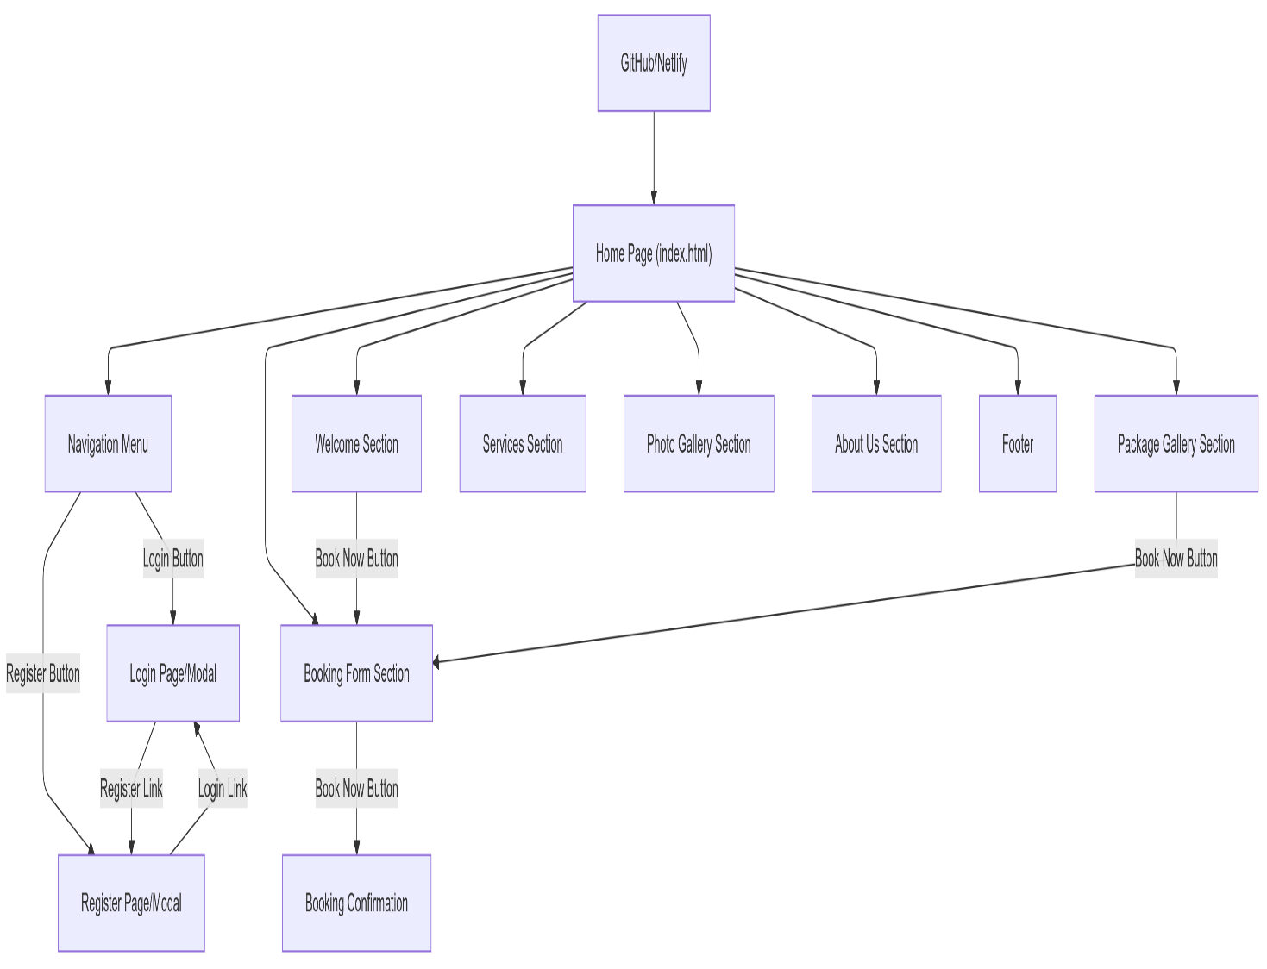

**Coding**

**1. HTML (Hypertext Markup Language)**

HTML was used as the foundational markup language to structure the content on the webpage, including the navigation, forms, sections, and various other elements.

* Usage: Defining the structure of the web page and adding semantic tags like <header>, <nav>, <section>, <footer>, etc.
* Key Elements:
  + Forms for user input.
  + Navigation menus for seamless user experience.
  + Semantic tags for better accessibility and SEO.

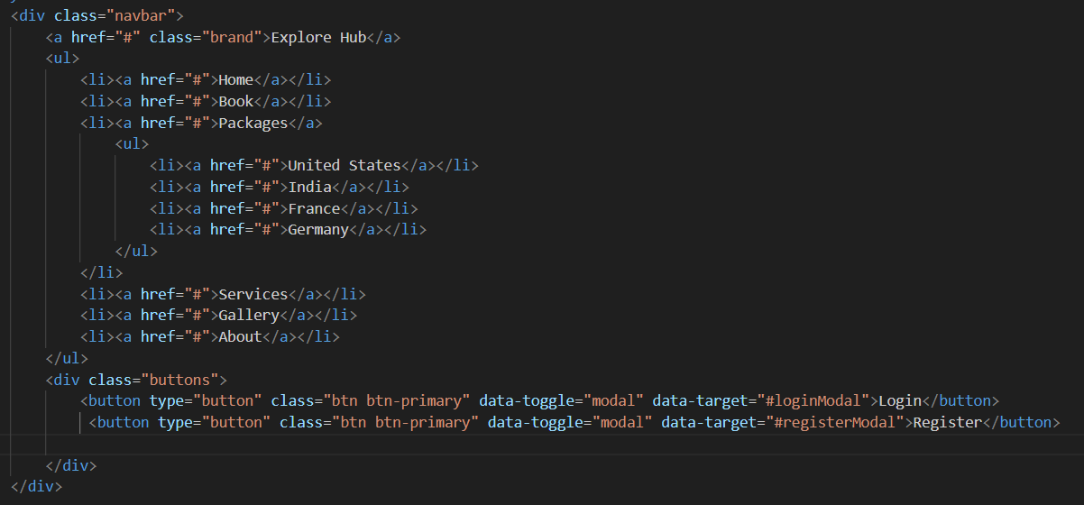

**2. CSS (Cascading Style Sheets)**

CSS was used to style the website, making it visually appealing and responsive to different screen sizes.

* Usage: Layout styling, color scheme, font styling, and media queries for responsiveness.
* Key Features:
  + Responsive Design: Ensured that the website is mobile-friendly and adapts to different screen sizes using media queries.
  + Hover Effects: For interactive elements like buttons, images, and navigation links.
  + Flexbox & Grid Layout: To create flexible and responsive layouts for the page sections.

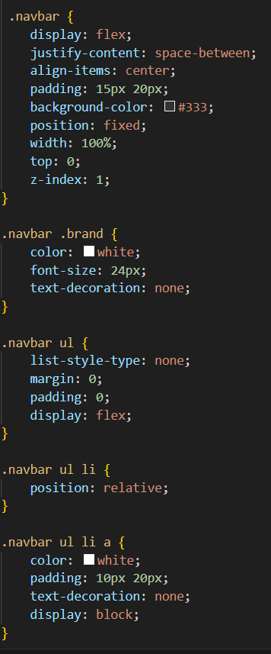

**3. JavaScript**

JavaScript was utilized for interactivity, validation, and dynamic content. This includes form validation, interactive elements, and creating a dynamic dropdown menu for the Packages section.

* Usage: Form validation, dropdown menu behavior, interactive button functionality, etc.
* Key Features:
  + Form Validation: Ensures that all form fields are filled correctly before submission.
  + Dropdown Menu Behavior: Packages dropdown dynamically displays options when hovered over.
  + Dynamic Content (e.g., country names): For a rotating list of country names in the homepage hero section.

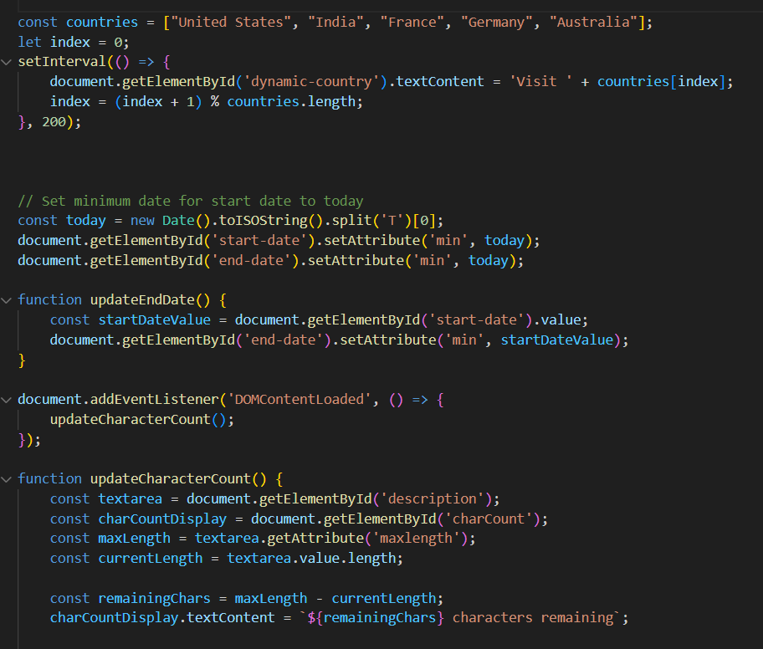

1. **Output**

https://github.com/NandiniRSangeetha/Front-End-Project.git

**Check Point 1**

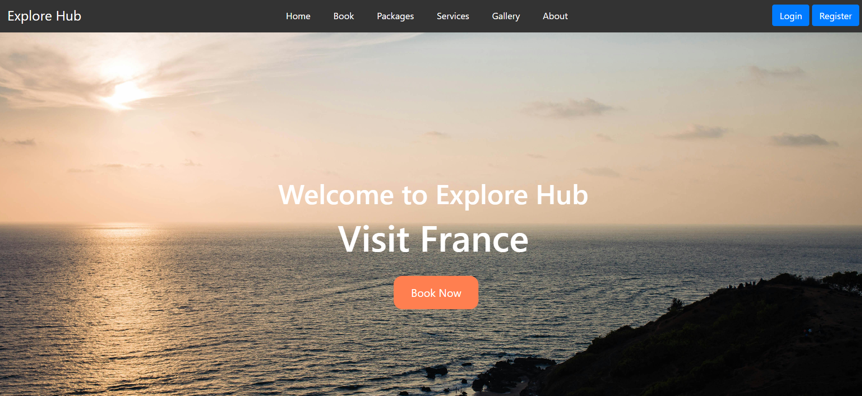

**Check Point 2**

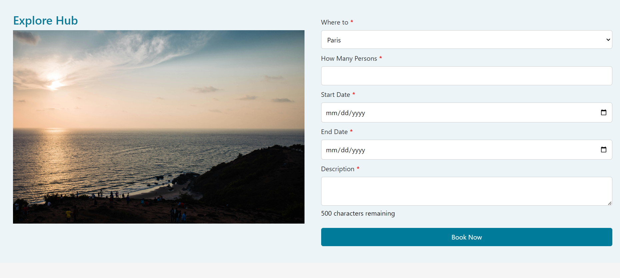

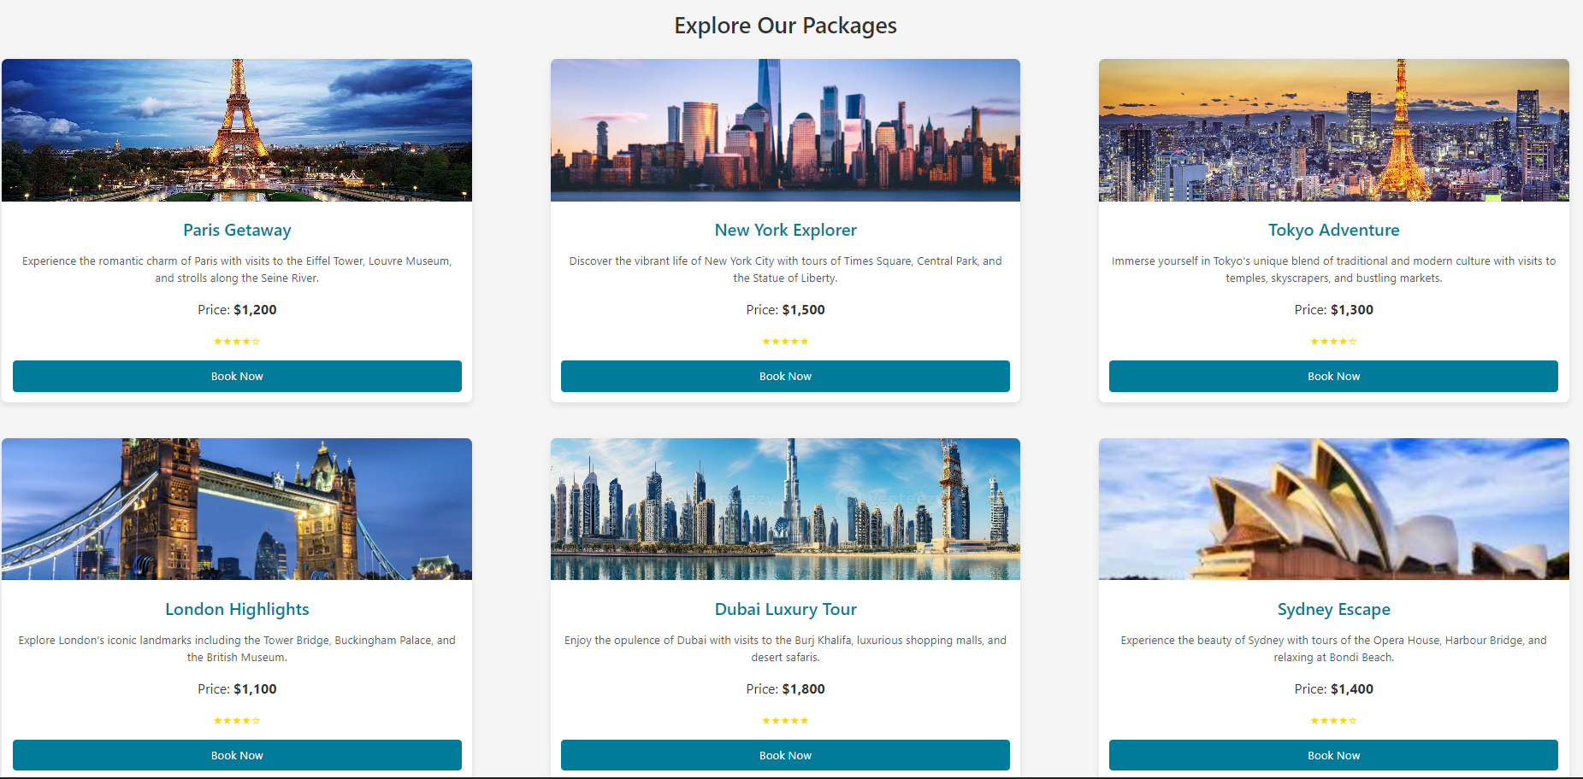

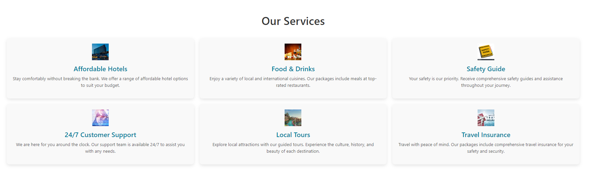

**Check Point 3**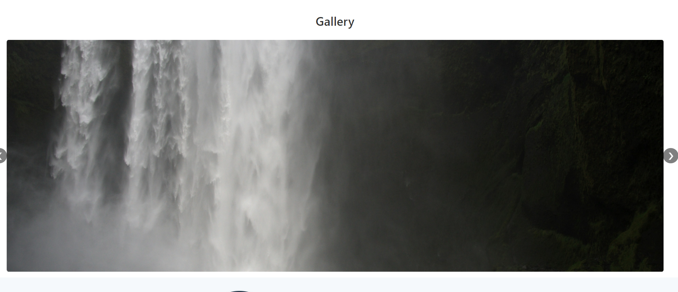

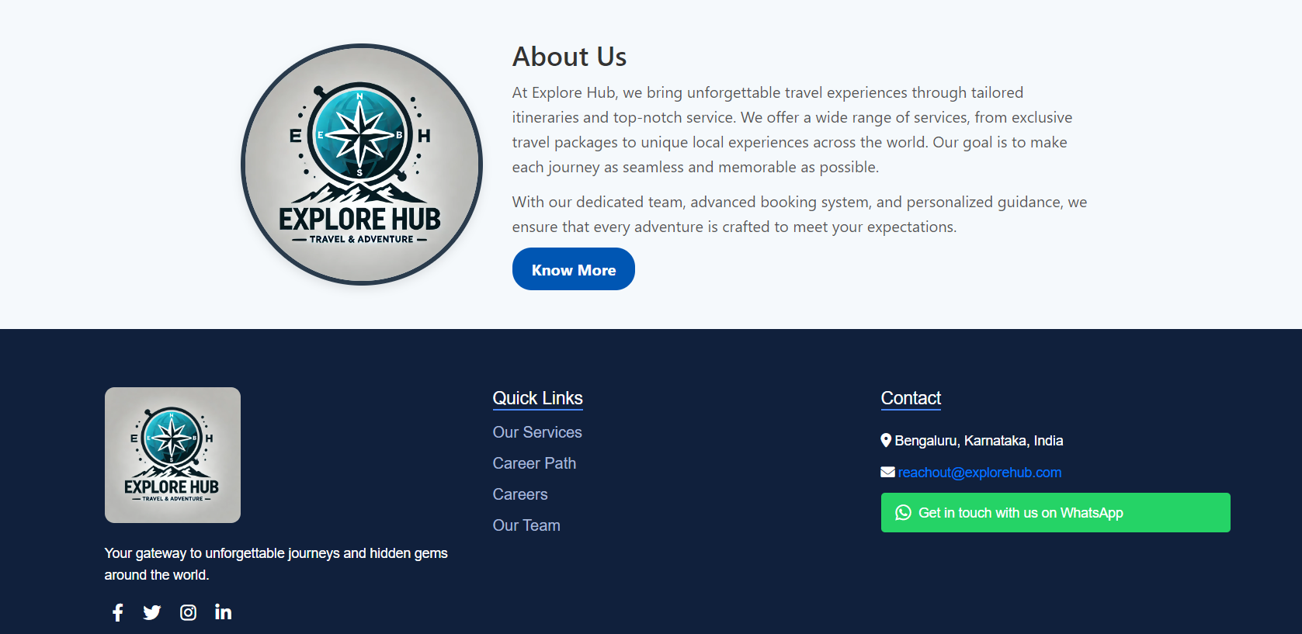

**Check Point 4**

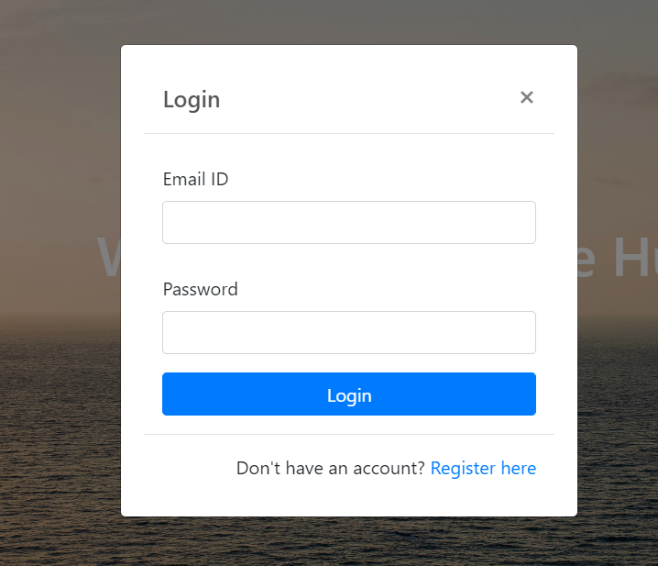

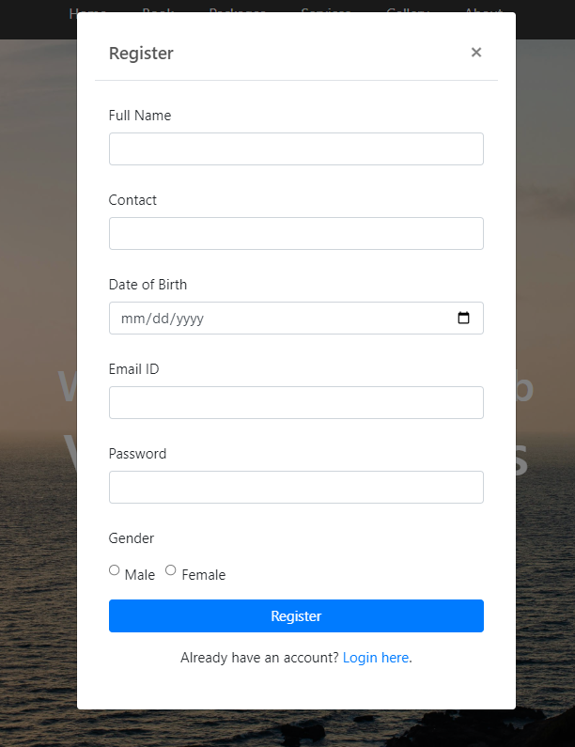

**8. Validation**

**1. JavaScript Form Validation**

Form validation ensures that the user input is correct before the form is submitted, preventing errors and improving the user experience.

Implementation:

JavaScript was used extensively to validate form inputs, particularly for the booking form and user registration. The following fields were validated:

* Email Validation:  
  Ensures that the email entered by the user is in the correct format (e.g., example@domain.com). This was done using a regular expression (RegEx) pattern to validate the email format.
* Password Validation (Registration Form):  
  Enforces strong password criteria to increase security. The password must:
  + Be at least 8 characters long.
  + Contain at least one uppercase letter.
  + Include at least one special character (e.g., @, #, !).
  + Have at least one number.
* Date Validation (Start & End Dates):  
  Ensures that:
  + The start date is always in the future (no past dates).
  + The end date is later than the start date (no conflicting or illogical dates).
* Text Area Validation (Booking Form):  
  Ensures that the description entered by the user is between 50 and 500 characters. This avoids users entering too little or too much information.
* Error Handling and Alerts:  
  If any validation fails, the user is shown an alert with a specific error message, pointing out what needs to be corrected before submitting the form. This provides real-time feedback and ensures that users don’t submit incomplete or incorrect data.

Tools/Technologies Used:

* Vanilla JavaScript: For implementing custom validation functions.
* RegEx (Regular Expressions): For email and password validation patterns.
* Alert Box (JavaScript): For showing error messages and successful submission confirmation.

**2. HTML5 Built-in Form Validation**

HTML5 offers built-in validation features that were leveraged to reduce the amount of custom JavaScript code required, and to ensure consistency and standardization.

Implementation:

* Required Fields:  
  HTML5 <input> tags for email, password, and date fields used the required attribute to make sure users fill in these fields before submitting the form.
* Pattern Matching (for Password and Email):  
  The pattern attribute in HTML5 was used for custom validation of email formats and password structure, ensuring that users adhere to specific formats directly in the HTML.
* Min/Max Length and Range:  
  The minlength and maxlength attributes were applied to the description field in the booking form, ensuring the text area contained between 50 and 500 characters.

Tools/Technologies Used:

* HTML5 form controls and validation attributes such as required, pattern, minlength, maxlength, type="email", and `type="date" ensure built-in checks before JavaScript intervention.

**3. Client-Side Validation Tools**

To streamline the validation process and provide more advanced, reusable functionality, third-party libraries and tools were used to improve user feedback and form handling.

Implementation:

* jQuery Validation Plugin:  
  While the project primarily uses vanilla JavaScript for validation, the jQuery Validation Plugin was also considered for client-side validation. It simplifies error handling and provides a more interactive user interface, such as highlighting the fields that need correction. This plugin offers features like:
  + Automatic field validation as the user types.
  + Customizable error messages.
  + Handling different input types (email, URL, etc.).

Example: If the user enters an invalid email, the plugin will display a helpful message like, "Please enter a valid email address."

Tools/Technologies Used:

* jQuery Validation Plugin:  
  Reference: jQuery Validation Plugin. (2024). *jQuery Validation*. <https://jqueryvalidation.org/>

**4. Cross-Browser Testing & Validation**

Ensures the website works consistently across different browsers and devices by validating cross-browser compatibility.

Implementation:

* Browser Testing:  
  The website was tested across major browsers (Google Chrome, Mozilla Firefox, Safari, Microsoft Edge) to ensure compatibility and correct rendering of elements, particularly for CSS and JavaScript features.
* Developer Tools (Browser DevTools):  
  Used browser developer tools to identify and fix rendering issues (e.g., mismatched margins or broken layouts) and ensure that the CSS and JavaScript behave as expected across browsers.
* CSS Validation (W3C CSS Validator):  
  The website's CSS was validated using the W3C CSS Validator tool to ensure the stylesheets comply with web standards and have no errors or warnings.
* HTML Validation (W3C Markup Validator):  
  The HTML code was validated through the W3C Markup Validator to ensure the structure is well-formed and adheres to HTML5 standards, preventing issues like broken links or incorrect markup.

Tools/Technologies Used:

* Google Chrome DevTools: For inspecting, debugging, and optimizing front-end code.
* W3C CSS Validator: <https://jigsaw.w3.org/css-validator/>
* W3C HTML Validator: <https://validator.w3.org/>

**5. Performance Validation**

Ensures the website loads quickly and efficiently on various devices, improving user satisfaction and search engine optimization (SEO).

Implementation:

* Lazy Loading of Images:  
  Implemented lazy loading for images in the gallery and booking sections, ensuring images load only when they are about to enter the viewport. This helps reduce initial page load time, improving overall performance.
* Minification of JavaScript and CSS Files:  
  To reduce file sizes and improve load times, JavaScript and CSS files were minified using tools like Terser (for JavaScript) and CSSNano (for CSS).
* Responsive Design and Mobile Optimization:  
  Ensured that the website was designed to be responsive, using media queries in CSS to adapt the layout for different screen sizes. This ensures the website performs well on mobile devices and tablets.

**6. Continuous Testing and Debugging**

Ensures the project functions correctly through various stages of development and that all features work together without issues.

Implementation:

* Unit Testing (if applicable):  
  For more complex functionalities (e.g., booking form validation), unit tests were written in Jest (if applicable) to ensure the JavaScript functions behave as expected.
* Manual Testing:  
  Extensive manual testing was conducted to ensure that every feature works as intended, from form submissions to navigation interactions and mobile responsiveness.

**9. Conclusion**

The **Travel Booking Website** is a responsive, dynamic website that offers users the ability to explore various travel packages, book their trips, and interact with services offered by a travel company. The website is designed to be user-friendly and interactive, featuring navigation bars, dropdown menus, background images, and dynamic content.\

**Key Features:**

* **Navigation Menu** with links for booking, services, gallery, and more.
* **Package Gallery** displaying different travel packages with essential details.
* **Booking Form** for users to input their travel plans, including dates, destinations, and number of people.
* **Interactive Gallery Section** showing user experiences.
* **Modal Forms** for login and registration, with proper validation.
* **Responsive Layout** for desktop, tablet, and mobile devices.
* **Footer** with company details, social media links, and copyright information.

The website should provide a seamless and enjoyable user experience while making it easy to book travel packages and learn about the company’s services. The project also incorporates essential front-end practices such as form validation, CSS design, and JavaScript interactivity.

**References**

**1. Frameworks and Libraries**

These are tools and libraries that were used to speed up development, enhance functionality, or improve the design of your project.

* Bootstrap: A front-end framework used for building responsive and mobile-first websites. It helps with layout, styling, and adding interactive components.
  + Reference:  
    Bootstrap. (2024). Bootstrap 5 Documentation. https://getbootstrap.com/docs/5.0/getting-started/introduction/
* jQuery: A JavaScript library that simplifies DOM manipulation, event handling, and AJAX calls (if used).
  + Reference:  
    jQuery Foundation. (2024). jQuery Documentation. <https://jquery.com/>
* Font Awesome: A library for scalable vector icons that can be customized with CSS, commonly used for social media icons, buttons, and other UI elements.
  + Reference:  
    Font Awesome. (2024). Font Awesome 6 Documentation. <https://fontawesome.com/>

**2. JavaScript Libraries**

These are JavaScript tools used to add extra functionality or interactivity to your website.

* Moment.js: A library used to manipulate and display dates and times.
  + Reference:  
    Moment.js. (2024). Moment.js Documentation. <https://momentjs.com/>

**3. Tools Used for Development**

List the tools you used to develop, test, or deploy the project. These could include:

* VS Code: A source-code editor that you likely used for writing HTML, CSS, and JavaScript.
  + Reference:  
    Visual Studio Code. (2024). Visual Studio Code Documentation. <https://code.visualstudio.com/docs>
* GitHub: Git for version control and GitHub for repository hosting and version management.
  + Reference:  
    GitHub, Inc. (2024). GitHub Documentation. <https://docs.github.com/en/github>

**4. Design Tools**

If you used any design tools for creating wireframes, mockups, or assets for the website, mention them here:

* Figma (or Adobe XD, Sketch): Tools for designing wireframes, prototypes, and visual assets.
  + Reference:  
    Figma. (2024). Figma Design Tool. <https://www.figma.com/>
* Canva: If you used it to create social media assets, logos, or promotional images.
  + Reference:  
    Canva. (2024). Canva Design Platform. <https://www.canva.com/>

**5. Tutorials or Documentation**

If you referred to any online tutorials, articles, or official documentation to help you during development, cite them as well.

* MDN Web Docs (for HTML, CSS, or JavaScript references):
  + Reference:  
    Mozilla. (2024). MDN Web Docs. <https://developer.mozilla.org/>
* W3Schools (if you referred to any coding examples):
  + Reference:  
    W3Schools. (2024). W3Schools Online Web Tutorials. <https://www.w3schools.com/>